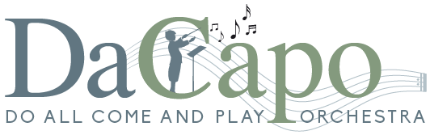 |  | Orchestra Open Day  Booking Form
Saturday, 5th September 2026
Main Hall, Kings Academy Prospect School, Cockney Hill,
Tilehurst, Reading RG30 4EX, UK
Registration at 9.30am for a 10am start, finish at 4pm

Please note this event is only open to persons 16 years or older
Name(s) | Click or tap here to enter text.
Phone | Click or tap here to enter text.
Email | Click or tap here to enter text.
Instrument | Click or tap here to enter text. |  | Approximate Grade | Click or tap here to enter text.
Age | ☐ I am 18 years or older |  | ☐ I am 16-18 years old
Fee (including hot drinks and cake at the morning and afternoon breaks)  Please bring your own mug and don’t forget to bring your lunch. |  |  |  | £25 per person
Music will be sent once payment has been received.
Please remember to bring a music stand.
Payment (Please tick the appropriate box)
Cheques ☐ |  |  | BACS Payments ☐
Payable to Da Capo and send your form and payment to:  Ian Haslam,  Da Capo Open Day  25, Cromwell Road, Shaw,  Newbury, RG14 2HP |  |  | Account Name: Da Capo  Sort Code: 23-05-80  Account No: 29187177  (please ensure you put your name against the payment as the reference)  You may scan the form and send to  openday@da-capo.org.uk
Please send your completed booking form and payment asap, and no later than 16th August 2026
www.da-capo.org.uk

